Q1: I would like you to list all servers which can be installed in companies, factories and schools. Especially for schools when I would like to install a smart school AI engine on it.
A1: For a smart school AI engine, company AI system, or factory automation system, you usually do not choose a server only by brand. You choose by workload type:
- Normal applications → CPU server
- Database / ERP / LMS → CPU + RAM + storage server
- AI chatbot / LLM / computer vision → GPU AI server
- Factory vision / robotics → Edge AI server
- Large AI training → GPU cluster / HPC server
Modern AI servers often use NVIDIA GPU acceleration because GPUs are optimized for deep learning workloads. (NVIDIA)
Below is a complete classification.

1. General Enterprise Servers (Companies, Schools, Offices)
These are the most common servers.

Dell PowerEdge Series
Dell Technologies
Examples:

Dell PowerEdge R Series (Rack Server)
Model | Usage
R250/R260 | Small schools, offices
R450/R550 | Medium applications
R650/R660 | Enterprise applications
R750/R760 | Database, virtualization
R860/R960 | Large enterprise
Good for:
- Student information system
- School management software
- Website hosting
- Database
- File server
- Virtual machines

HPE ProLiant Series
Hewlett Packard Enterprise
Popular models:
Model | Usage
DL20 Gen11 | Small business
DL320 Gen11 | Entry enterprise
DL360 Gen11 | General enterprise
DL380 Gen11 | Most popular
DL560 Gen11 | High CPU workloads
Good for:
- ERP
- School LMS
- Research systems
- Private cloud

Lenovo ThinkSystem
Lenovo
Examples:
Model | Usage
SR250 | Small schools
SR630 | Enterprise
SR650 | Database / virtualization
SR850 | Large workloads

2. AI Servers (Recommended for Smart School AI)
For a smart school AI engine, these are more important.
A typical smart school AI system may include:
- AI teacher assistant
- Student Q&A chatbot
- Automatic grading
- English pronunciation analysis
- Knowledge base search
- Student performance prediction
- Video monitoring
- Face recognition
- Personalized learning
These need GPU servers.

NVIDIA AI Servers
NVIDIA
NVIDIA provides AI platforms and GPU acceleration technologies used in AI infrastructure. (NVIDIA)

NVIDIA DGX Systems
Enterprise AI supercomputer.
Examples:
Server | Usage
DGX H100 | Large AI training
DGX H200 | Large LLM
DGX B200 | Next-generation AI
DGX SuperPOD | Massive AI cluster
Suitable for:
- National AI education platform
- University AI research
- Large language model training
Cost:
- Usually hundreds of thousands to millions USD

3. Practical AI Servers for Schools
For most schools, DGX is too expensive.
Better choices:

Dell PowerEdge + NVIDIA GPU
Example:
Dell PowerEdge R760xa
Configuration:
- Intel Xeon CPU
- 256GB–1TB RAM
- NVIDIA RTX 6000 Ada / L40S / A100 GPU
Good for:
- Local AI chatbot
- RAG system
- Teacher assistant
- Offline AI

HPE ProLiant GPU Servers
Example:
HPE ProLiant DL380a
Can support:
- NVIDIA L40S
- NVIDIA A100
- NVIDIA H100

Supermicro GPU Servers
Supermicro
Very popular among AI companies because they are flexible.
Examples:
Model | GPU
SuperServer 4029GP | 4 GPUs
SYS-421GE | 8 GPUs
AS-8125GS | AMD EPYC + GPUs
Good price/performance.

4. Edge AI Servers (Factories, Smart Campus)
These are installed near cameras and machines.
Used for:
- Factory inspection
- Security cameras
- Robotics
- Smart classroom cameras
Examples:

NVIDIA Jetson
Small AI computers.
Models:
Model | Usage
Jetson Orin Nano | Small AI
Jetson Orin NX | Edge AI
Jetson AGX Orin | Industrial AI
Good for:
- Camera analysis
- Robot control
- Smart classroom devices

5. Storage Servers
Schools and factories need huge storage.

NAS Servers
Popular:
Synology
Examples:
- Synology RackStation
- Synology DiskStation
Usage:
- Student files
- Videos
- Documents
- Backup

Enterprise Storage
Examples:
- Dell PowerStore
- HPE Alletra
- NetApp Storage
For:
- Large universities
- Government education systems

6. Database Servers
For:
- Student database
- ERP
- School management system
Typical configuration:
CPU:
- Intel Xeon
- AMD EPYC
RAM:
- 128GB–1TB
Storage:
- NVMe SSD RAID
Examples:
- Dell R760
- HPE DL380
- Lenovo SR650

7. Virtualization Servers
One physical server runs many virtual servers.
Software:
- VMware ESXi
- Proxmox
- Microsoft Hyper-V
- KVM
Example:
One server:
Physical Server

|
|
--------------------
| | |
School AI Database Website
VM VM VM
Very common in companies and schools.

8. Factory Industrial Servers
Factories need special servers.
Requirements:
- Dust resistance
- Long operation
- Temperature tolerance
Brands:

Siemens Industrial PCs
Used for:
- PLC
- Manufacturing

Advantech Industrial Servers
Used for:
- Factory automation
- IoT

Beckhoff Industrial PCs
Used for:
- Industrial control

9. High Performance Computing (HPC)
For:
- Universities
- Research
- Advanced AI
Examples:

HPE Cray
Used for supercomputers.

NVIDIA SuperPOD
Large AI clusters.

AMD Instinct Servers
Using AMD AI GPUs.

Recommended Smart School AI Architecture
For a medium-sized school (1,000–5,000 students), I would not recommend a supercomputer.
A realistic architecture:
Internet
|
Firewall
|
-----------------
| |
Web Server AI Server
|
NVIDIA GPU Server
|
--------------------
| |
LLM Model Vector DB
(Llama/Qwen) (Milvus)
|
Student Database

Recommended Hardware Levels

Level 1: Small School
Cost:
$5,000–15,000
Server:
- Dell PowerEdge R550
- Xeon CPU
- 128GB RAM
- RTX 4090 / RTX 6000 GPU
Can run:
- AI chatbot
- English assistant
- Teacher assistant

Level 2: Medium School
Cost:
$20,000–80,000
Server:
- Dell/HPE GPU server
- NVIDIA L40S
- 256GB–512GB RAM
Can run:
- Local LLM
- RAG system
- AI grading
- Student analytics

Level 3: University / Government Education Platform
Cost:
$200,000+
Server:
- NVIDIA H100/H200
- DGX systems
- GPU cluster

For your previous smart school idea (offline Korean Q&A database)
You mentioned:
- no internet environment
- 5 years of Korean teacher Q&A data
- local AI engine
- continuous learning
For that case, you do not need a huge AI training server.
A good design:
Hardware:
- Dell PowerEdge R760
- 256GB RAM
- 2× NVIDIA RTX 6000 Ada / L40S
- 4–8TB NVMe
Software:
- Linux Ubuntu Server
- Ollama / vLLM
- Qwen2.5 / Qwen3 Korean-capable LLM
- LangChain / LlamaIndex
- Milvus / ChromaDB
- PostgreSQL
This can become a complete offline Smart School AI platform.
For a school project, this type of private AI server is usually more realistic than cloud AI because student data stays inside the school. (Express Computer)
I can also provide a complete Smart School AI server BOM (hardware list + price + number of students supported) if you want.
Q2: Can you recommend to me the best structure of installing servers in a school? Those servers have to support not only smart school systems but also more web applications which are developed by students and teachers.
A1:
Yes. For a school environment, I would not recommend installing separate physical servers for every application. A better design is a private school data center architecture with:
- Core infrastructure servers
- Application hosting platform
- AI infrastructure
- Database and storage
- Student/teacher development environment
- Security and backup systems
The goal is:
- Run the Smart School AI system
- Host school websites and applications
- Allow students and teachers to deploy projects
- Protect important school data
- Scale for future growth
A good architecture looks like this:
Internet
|
Firewall / Router
|
Core Switch
|
--------------------------------
| | |
Server Cluster Storage Backup
|
|
Virtualization Platform
|
------------------------------------------------
| | | |
AI System Web Apps Database Dev Platform
VM VM VM VM

Recommended School Server Structure

Layer 1: Firewall + Network Security

Hardware
Examples:
- Fortinet Firewall
- Palo Alto Firewall
- Sophos Firewall
- OPNsense (open source)
Responsibilities:
- Internet security
- VPN
- User authentication
- Network separation
Create separate networks:
VLAN 10 Administration
VLAN 20 Teachers
VLAN 30 Students
VLAN 40 Servers
VLAN 50 AI System
VLAN 60 IoT / Cameras
This is very important.
A student project should never directly access the student database.

Layer 2: Virtualization Cluster (The Heart)
Instead of:
Server 1 = Website
Server 2 = Database
Server 3 = AI
Server 4 = Student projects
Use:
Physical Servers
|
|
Virtualization
|
-----------------------
| | | | |
AI DB Web LMS Apps
VM VM VM VM VM
Recommended platforms:

Option A (Commercial)
VMware vSphere
Very stable but expensive.

Option B (Recommended for schools)
Proxmox VE
Advantages:
- Free
- Open source
- Supports VM + containers
- Easy management

Physical Server Cluster
For a medium school:

3-node cluster
Example:

Server Node 1
CPU:
- AMD EPYC / Intel Xeon
RAM:
- 256GB
Storage:
- 4TB NVMe

Server Node 2
Same.

Server Node 3
Same.
Why 3 servers?
Because:
Server A fails

↓

Server B + C continue running
High availability.

Layer 3: Smart School AI Server
AI should be separated.
Do not put AI workloads on the same server as websites.
Example:
AI Server

GPU:
NVIDIA L40S
or
RTX 6000 Ada

RAM:
256GB-512GB

Storage:
4TB NVMe
Runs:
- AI teacher assistant
- Student chatbot
- Automatic grading
- English learning AI
- Knowledge search
- Student prediction models
Software:
Ubuntu Server

|
|
Docker

|
----------------------
| |
LLM Vector Database
(Qwen/Llama) (Milvus)

Layer 4: Application Hosting Platform
This is where students and teachers deploy applications.
I recommend:

Kubernetes
Architecture:
Students

|
Git Repository

|
CI/CD

|
Kubernetes Cluster

|
Applications
Example student projects:
project-a.school.edu
project-b.school.edu
project-c.school.edu
Each project runs isolated.
Technologies:
- Docker
- Kubernetes
- GitLab
- Jenkins
- GitHub Enterprise

Layer 5: Database Servers
Separate databases.
Do not let every application install its own database.
Structure:
Database Cluster

PostgreSQL
|
-----------------
| | |
AI DB LMS DB Apps DB
Recommended:
- PostgreSQL
- MySQL
- Redis
Hardware:
RAM:
128GB+
Storage:
NVMe SSD RAID

Layer 6: Storage Server
Schools generate huge data:
- Student videos
- AI training data
- Documents
- Research projects
- Backup
Use:

NAS/SAN
Examples:
- Synology RackStation
- TrueNAS
- Dell PowerVault
Storage:
50TB–200TB
Structure:
Storage Server

|
|-- Student files
|
|-- AI datasets
|
|-- Application backups
|
|-- Videos

Layer 7: Development Platform for Students
This is very important.
Create a "School Developer Cloud".
Students get:
Student Account

|
|
Virtual Workspace

|
-----------------
| |
Python Node.js
React Django
Java AI Tools
Tools:
- GitLab
- JupyterHub
- VS Code Server
- Docker
Students learn:
- Software engineering
- AI development
- Cloud deployment

Layer 8: Backup System
Never put everything on one server.
Recommended:

3-2-1 Backup Rule
3 copies

2 different storage types

1 offline copy
Example:
Main Server

|
|
Backup Server

|
|
External Storage

Example Complete Hardware for a 3,000 Student School

Server Room

Compute Cluster
3 × Dell PowerEdge R760
Each:
- 64 cores CPU
- 256GB RAM
- 4TB NVMe
Purpose:
- Websites
- LMS
- Applications
- Virtual machines

AI Server
1 × GPU Server
Example:
Supermicro / Dell
- NVIDIA L40S × 2
- 512GB RAM
- 8TB NVMe
Purpose:
- Smart school AI

Storage
1 × NAS
- 100TB storage

Backup
1 × Backup server
- 50TB

Software Stack I Would Choose
For a modern AI-focused school:
Operating System:
Ubuntu Server

Virtualization:
Proxmox

Containers:
Docker

Orchestration:
Kubernetes

AI:
Ollama / vLLM

LLM:
Qwen / Llama

RAG:
LlamaIndex

Vector DB:
Milvus

Database:
PostgreSQL

Storage:
TrueNAS

Development:
GitLab + VS Code Server

Monitoring:
Grafana + Prometheus

My Recommended Final Architecture
For a school that wants to become an AI + software development education center:
Internet
|
Firewall
|
Core Network
|
-------------------------
| |
Proxmox Cluster GPU AI Server
| |
| |
---------------- ----------------
| | | | |
Web DB Dev LLM RAG
VM VM VM Server DB

|
Storage System
|
Backup System
This structure can support:
✅ Smart school AI
✅ Teacher tools
✅ Student-developed applications
✅ Research projects
✅ School websites
✅ Online learning platform
✅ AI training platform
✅ Future expansion
For your previous idea (offline Korean education AI with 5 years of Q&A data), this architecture is actually close to how a university AI lab or government education platform would be designed.
Q3: Can you give me a diagram how we can setup all the servers?
A3:
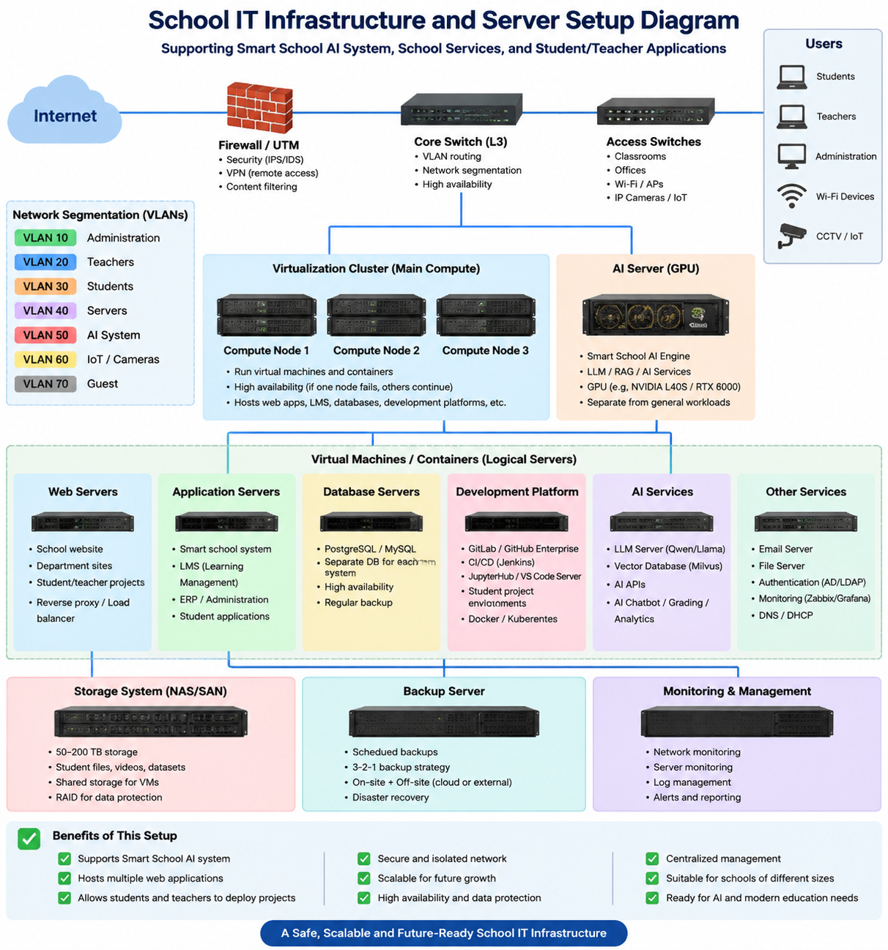
Q4: Thanks. Can you produce a perfect design and installation guide step by step?
A4:
I created a polished 15-page design and step-by-step installation guide.
It includes:
- Complete server and network architecture
- Hardware bill of materials
- VLAN and IP addressing plan
- Three-node Proxmox cluster
- Dedicated GPU AI server
- Storage and independent backup servers
- Protected school applications and databases
- Isolated student and teacher development platform
- Korean offline Q&A and RAG architecture
- Firewall and security rules
- Installation phases and example commands
- Monitoring and maintenance routines
- Backup and disaster-recovery testing
- Commissioning and acceptance checklist
- Migration and rollout schedule
Download the Smart School Server Design and Installation Guide
This is a reference design for approximately 1,000–3,000 users. Final hardware quantities should be adjusted after confirming student count, concurrent AI users, applications, data volume, camera workload, budget, and availability requirements.
[ Guide included: smart_school_server_design_installation_guide]

